**Create a Strong Password and Evaluate Its strength**

**1. Multiple Passwords with Varying Complexity*:***

1. simple123
2. MyPassword2025
3. P@ssw0rd!#
4. H$7rT!x9&Qz3;
5. 4uB#nT!s2pL@2025
6. **Components Used:**

All passwords include different combinations of uppercase, lowercase, numbers, and symbols. They also vary in length to test complexity impact.

1. **Password Strength Test Results:**
2. simple123 – Weak (easily guessable)

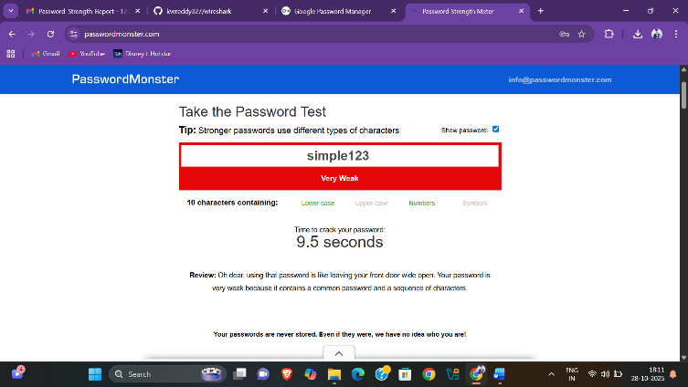

1. MyPassword2025 – Medium (common pattern)

1. P@ssw0rd!# – Strong (uses mixed characters)

1. H$7rT!x9&Qz3; – Very Strong (high entropy)

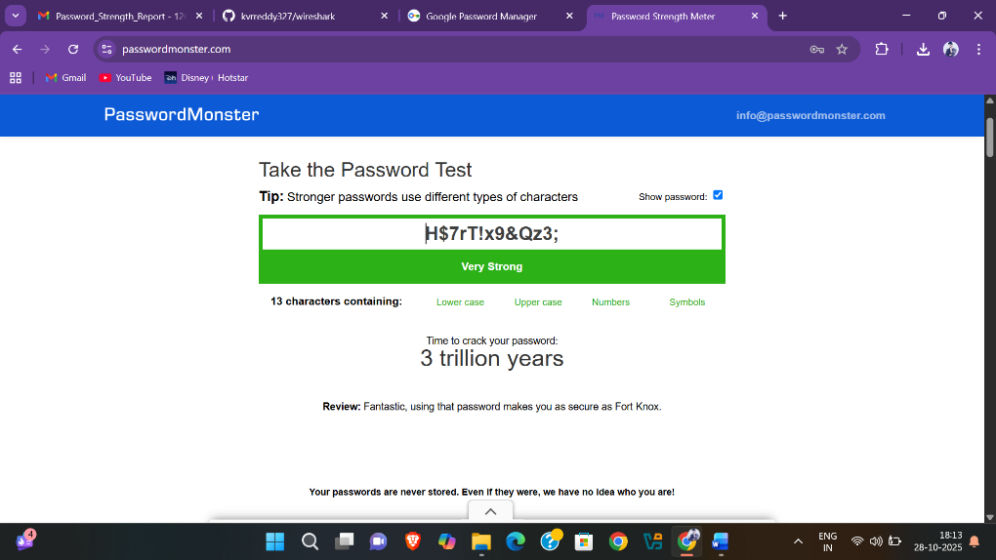

1. 4uB#nT!s2pL@2025 – Very Strong (complex and long)

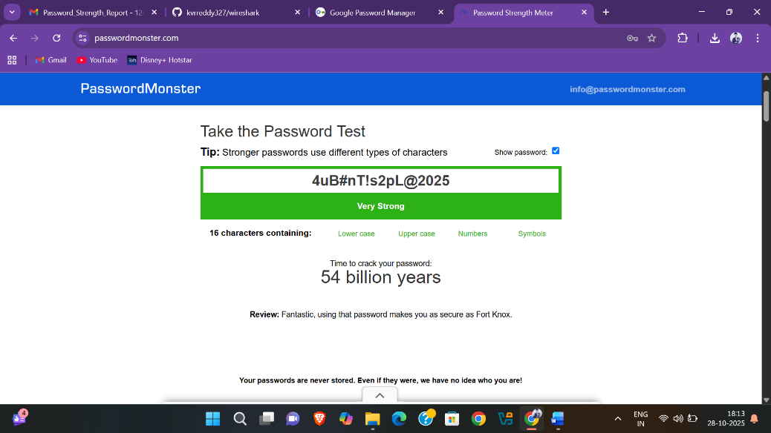

1. **Observations and Feedback:**

Stronger passwords contain random characters, special symbols, and are at least 12–16 characters long. Avoid dictionary words and predictable substitutions like 'P@ssw0rd'.

1. **Best Practices Identified:**

* Use 12+ characters.
* Mix upper, lower, numbers, and symbols.
* Avoid personal info and real words.
* Use passphrases (e.g., 'Mango$Skyline@2025!').
* Use a password manager to store unique passwords.

**6. Tips Learned from Evaluation:**

* Randomness increases security.
* Longer passwords resist brute-force attacks.
* Reusing passwords across sites is risky.
* Avoid predictable patterns.

**7. Common Password Attacks:**

* **Brute Force Attack:** Tries every possible combination; long, complex passwords resist better.
* **Dictionary Attack:** Uses known word lists; random symbols and numbers protect against it.- **Phishing Attack:** Tricks users into revealing passwords; user awareness is key.

**8. Summary – How Complexity Affects Security:**

Password complexity significantly increases security. The inclusion of diverse characters and length makes it exponentially harder for attackers to guess or crack passwords. Simple or reused passwords remain the most common cause of security breaches.